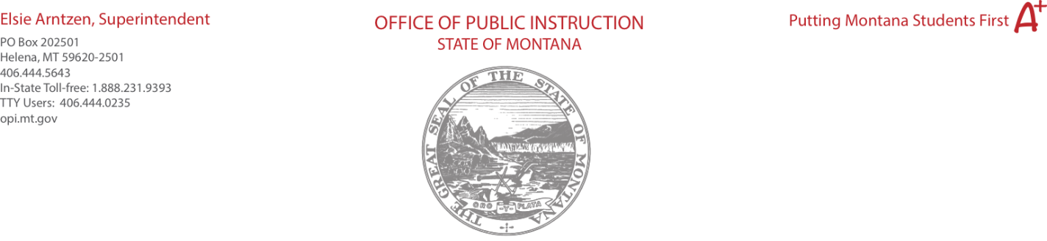

To: State Superintendent Elsie Arntzen
From: Variances to Standards Review Board
CC: Sharyl Allen, Asst. Deputy Superintendent, Linda Vrooman Peterson, Division
Administrator
Date: April 15, 2021

Re: Variances to Standards Review Board (VSRB) Recommendations to Superintendent Arntzen

Application 1
Bigfork Public Schools - Bigfork Elementary (SC:0442) and Bigfork 7-8 (SC:1660) ARM 10.55.709-Library Media Specialist FT, K‐12.

This application is an Initial Request (two years).

Recommendation: The VSRB recommends to approve the application for a variance to ARM 10.55.709 Library Media Services, K‐12 Bigfork Public Schools- Bigfork Elementary and Bigfork 7-8.

Vote: Unanimous

Application 2
Hardin Public Schools- Hardin High School (SC:0037)
ARM 10.55.709-Library Media Specialist FTE, K‐12.

This application is an Initial Request (two years).

Recommendation: The VSRB recommends to approve the application for a variance to ARM 10.55.709 Library Media Services, K‐12 from Hardin Public Schools-Hardin High School.

Vote: Unanimous

Application 3
Polson Public Schools- Polson High School (SC:0633) ARM 10.55.709-Library Media Specialist FTE and ARM 10.55.709-Library Media Program Delivery Standards, K‐12.

This application is an Initial Request (two years).

Recommendation: The VSRB recommends to approve the application for a variance to
ARM 10.55.709 Library Media Services, K‐12 from Polson High School.

Vote: Unanimous

Application 4
Bozeman Public Schools-Bozeman Online Charter School ARM 10.55.604(11) The procedure by which a school district may apply to create a charter school.

This application is an Initial Request (two years).

Recommendation: The VSRB recommends to approve the application for the Bozeman Online Charter School K-8, ARM 10.55.604 (11).

Vote: 5-2

Board Chair Signature:
